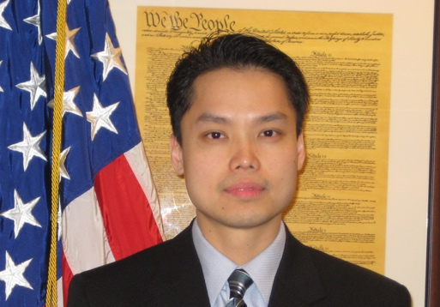

David Lum
Program Manager
IRS – Criminal Investigation
Cyber and Forensic Services

In 2000, David joined the Internal Revenue Service Criminal Investigation Division as a Special Agent in the New York Field Office. His field investigative assignments included investigating kickbacks schemes, violations of the foreign corrupt practice act, tax evasion, corporate fraud, cybercrime, and money laundering. His investigations have resulted in prosecutions along with tens of millions of dollars in forfeiture, seizures and restitution to the government and victims. Notable case includes violation of the foreign corrupt practice act by a major oil company.

In 2014, David was promoted to Supervisory Special Agent of the El Dorado Task Force. As a task force manager, David oversaw a multi-agency group specializing in OCDETF investigations, international financial investigations, and investigations involving complex money laundering organizations. Notable case includes money laundering by a major financial institution.

In 2015, David was appointed to International Operation as the Deputy Attaché of the Hong Kong Post. In 2016, David was appointed as the Attaché, head of the Hong Kong Post, whose area of responsibility spans 25 jurisdictions in the Asia region. He oversaw and was responsible for all investigative activities with nexus to Asia. Notable cases include the largest international kleptocracy investigation; and take down of the largest dark market and largest dark web child porn marketplace.

In 2021, David took a position in IRS HQ as a program manager with the Cyber Crime Section. He is responsible for overseeing policy on cybercrime and digital assets, developing cyber training program, supporting field operations related to cybercrime investigations, and researching new technologies.

David has also been actively involved with the National Asian Peace Officers’ Association (NAPOA). In 2009, he was elected National President by NAPOA’s Board of Directors. Additionally, David has also been an active member of the Society of Asian Federal Officers (regional chapter of NAPOA) and has held various positions on its Executive Board, including President.

