Larry A. Smith
Assistant Administrator/
Chief Administrative Officer
Security and Administrative Services

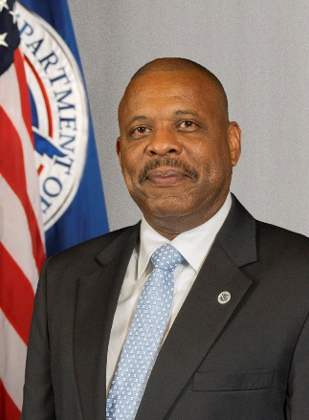

Larry A. Smith serves as the Assistant Administrator for Security and Administrative Services (SAS) and Chief Administrative Officer (CAO) for TSA. He is responsible for executive oversight, implementing comprehensive law enforcement and security, occupational safety and health, environmental management, real estate and facilities, real property acquisitions, records management, property, and fleet and transportation management.
During his tenure with TSA, he has served in several leadership roles, including Chief of the Personnel Security Section (PerSec). In that position, he provided supervision and management of all Personnel Security operations and policies. Mr. Smith previously served as the Deputy Assistant Administrator for SAS and Chief Security Officer for TSA.
Before joining TSA, he served as the Chief of Clearance Liaison Office, Defense Security Service (DSS), where he was responsible for strategic planning, financial management, policy development and implementation, and support functions that enabled DSS to execute its mission. He has also served in security and management positions with the U.S. Marshals Service, General Services Administration and the Defense Office of Hearings and Appeals.
Prior to his federal career, Smith served 24 years in the U.S. Marine Corps. Throughout his military career, he served in a wide variety of staff and operational intelligence assignments.
Mr. Smith is a graduate of the National Defense Intelligence College.

